**Group A : 01**

|  |  |
| --- | --- |
| Name | Abhishek Santosh Bankar |
| Roll No | 305A012 |
| Div | TE-1 |

















































































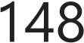







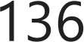





  



























































  





















































































































    

























**Group A : 02**

|  |  |
| --- | --- |
| Name | Abhishek Santosh Bankar |
| Roll No | 305A012 |
| Div | TE-1 |

import pandas as pd import numpy as np

import matplotlib.pyplot as plt import seaborn as sns

df= pd.read_csv('studentData.csv')

df.head()

**Email Address Name Email Roll no**

[mbare19@gmail.com](mailto:mbare19@gmail.com) Sejal Zambare

[thorat19@gmail.com](mailto:thorat19@gmail.com) Rushikesh

Vilas Thorat

[takke19@gmail.com](mailto:takke19@gmail.com) Atharv Sontakke

[sejal.zambare19@gmail.com](mailto:sejal.zambare19@gmail.com) TECOC359 72

[rushikesh.thorat19@gmail.com](mailto:rushikesh.thorat19@gmail.com) TECOC347 72

[atharv123sontakke@gmail.com](mailto:atharv123sontakke@gmail.com) TECOC340 72

[rekar19@gmail.com](mailto:rekar19@gmail.com)

[dekar19@gmail.com](mailto:dekar19@gmail.com)

Amisha

Sunil Sherekar

Saurabh

Raju Sawardekar

[amisha.sherekar19@gmail.com](mailto:amisha.sherekar19@gmail.com) TECOC328 72

[saurabh.sawardekar19@gmail.com](mailto:saurabh.sawardekar19@gmail.com) TECOC326 72

df.isnull()

**Timestamp**

|  |  |  |  |  |  |  |  |  |  |
| --- | --- | --- | --- | --- | --- | --- | --- | --- | --- |
|  | | | | | | | | **Sem 1** | **Sem 2** |
| **0** | False | False | False | False | False | False | False | False | False |
| **1** | False | False | False | False | False | False | False | False | False |

**Email Name Email Address**

**2** False False False False False False False False False

**3** False False False False False False False False False

**Roll**

**no**

**PRN**

**No.**

**Mobile**

**No.**

**First year:**

**First S year:**

df.isnull().sum()

|  |  |  |
| --- | --- | --- |
| Timestamp |  | 0 |
| Email Address |  | 0 |
| Name |  | 0 |
| Email |  | 0 |
| Roll no |  | 0 |
| PRN No. |  | 0 |
| Mobile No. |  | 0 |
| First year: | Sem 1 | 0 |
| First year: | Sem 2 | 0 |
| Second year: | Sem 1 | 0 |
| Second year:  dtype: int64 | Sem 2 | 0 |

df.describe()

**Mobile No. First year:**

**4** False False False False False False False False False

**...** ... ... ... ... ... ... ... ... ...

**59** False False False False False False False False False

**60** False False False False False False False False False

**61** False False False False False False False False False

**62** False False False False False False False False False

**63** False False False False False False False False False

|  |  |  |  |  |
| --- | --- | --- | --- | --- |
|  | **Sem 1** | **Sem 2** | **year: Sem 1** | **year: Sem 2** |
| **count** 6.400000e+01 | 64.000000 | 64.000000 | 64.000000 | 64.000000 |
| **mean** 8.623097e+09 | 8.834219 | 9.095469 | 9.292031 | 9.377187 |
| **std** 9.132070e+08 | 11.187839 | 11.171986 | 0.528523 | 0.495185 |
| **min** 7.028870e+09 | 0.000000 | 0.000000 | 6.900000 | 7.200000 |
| **25%** 7.766559e+09 | 7.237500 | 7.655000 | 9.050000 | 9.140000 |
| **50%** 8.805720e+09 | 8.260000 | 8.400000 | 9.445000 | 9.450000 |
| **75%** 9.335094e+09 | 8.802500 | 9.115000 | 9.645000 | 9.725000 |

**First year:**

**Second**

**Second**

plt.hist(df['Second year: Sem 1']) plt.show()

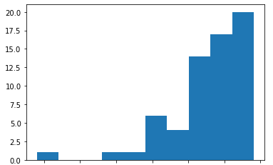

trueindex=(res.loc[lower_bound]<df['Second year:

trueindex

Sem 1'].values) & (df['Second year:

S

0.690

0.991

9.59940

9.88165

Name: Second year: Sem 1, dtype: float64

lower_bound=.69 upper_bound=.991

res=df['Second year: Sem 1'].quantile([lower_bound,upper_bound]) res

array([ True, False, False, False, False, False, True, False, False, False, False, True, True, False, False, False, True, True, False, False, True, False, True, True, False, False, False, False, False, False, False, True, False, False, False, True, True, True, False, True, False, False, False, False, True, False, True, False, False, False, True, False, False, False, False, True, False, False, True, False, False, False, False, False])

falseindex=~trueindex falseindex

array([False, True, True, True, True, True, False, True, True, True, True, False, False, True, True, True, False, False, True, True, False, True, False, False, True, True, True, True, True, True, True, False, True, True, True, False, False, False, True, False, True, True, True, True, False, True, False, True, True, True, False, True, True, True, True, False, True, True, False, True, True, True, True, True])

df['Second year: Sem 1'][trueindex]

|  |  |
| --- | --- |
| 0 | 9.80 |
| 6 | 9.68 |
| 11 | 9.77 |
| 12 | 9.77 |
| 16 | 9.68 |
| 17 | 9.86 |
| 20 | 9.64 |
| 22 | 9.82 |
| 23 | 9.86 |
| 31 | 9.86 |
| 35 | 9.64 |
| 36 | 9.75 |
| 37 | 9.66 |
| 39 | 9.86 |
| 44 | 9.70 |
| 46 | 9.67 |
| 50 | 9.61 |

55 9.73

58 9.63

Name: Second year: Sem 1, dtype: float64

mid=np.median(df['Second year: Sem 1'][trueindex]) mid

9.73

0s completed at 10:10 PM

**Group A : 03**

|  |  |
| --- | --- |
| Name | Abhishek Santosh Bankar |
| Roll No | 305A012 |
| Div | TE-1 |

# Assignment No. 3- Descriptive Statistics - Measures of Central Tendency and Variability

from google.colab import files uploaded = files.upload()

Iris.csv

Choose files

**Iris.csv**(text/csv) - 5107 bytes, last modiﬁed: 26/04/2022 - 100% done

Saving Iris.csv to Iris.csv

import pandas as pd import numpy as np

df = pd.read_csv('Iris.csv') df

virginica

|  |  |  |  |  |  |
| --- | --- | --- | --- | --- | --- |
|  | **Id** | **SepalLengthCm** | **SepalWidthCm** | **PetalLengthCm** | **PetalWidthCm Species** |
| **0** | 1 | 5.1 | 3.5 | 1.4 | 0.2 Iris-  setosa |
| **1** | 2 | 4.9 | 3.0 | 1.4 | 0.2 Iris-  setosa |
| **2** | 3 | 4.7 | 3.2 | 1.3 | 0.2 Iris-  setosa |
| **3** | 4 | 4.6 | 3.1 | 1.5 | 0.2 Iris-  setosa |
| **4** | 5 | 5.0 | 3.6 | 1.4 | 0.2 Iris-  setosa |
| **...** | ... | ... | ... | ... | ... ... |
| **145** | 146 | 6.7 | 3.0 | 5.2 | 2.3 Iris-  virginica |
| **146** | 147 | 6.3 | 2.5 | 5.0 | 1.9 Iris- |

df.shape

(150, 6)

### describe() function

df.describe()

|  |  |  |  |  |  |
| --- | --- | --- | --- | --- | --- |
|  | **Id** | **SepalLengthCm** | **SepalWidthCm** | **PetalLengthCm** | **PetalWidthCm** |
| **count** | 150.000000 | 150.000000 | 150.000000 | 150.000000 | 150.000000 |
| **mean** | 75.500000 | 5.843333 | 3.054000 | 3.758667 | 1.198667 |
| **std** | 43.445368 | 0.828066 | 0.433594 | 1.764420 | 0.763161 |
| **min** | 1.000000 | 4.300000 | 2.000000 | 1.000000 | 0.100000 |
| **25%** | 38.250000 | 5.100000 | 2.800000 | 1.600000 | 0.300000 |
| **50%** | 75.500000 | 5.800000 | 3.000000 | 4.350000 | 1.300000 |
| **75%** | 112.750000 | 6.400000 | 3.300000 | 5.100000 | 1.800000 |
| df.info() |  |  |  |  |  |

<class 'pandas.core.frame.DataFrame'> RangeIndex: 150 entries, 0 to 149 Data columns (total 6 columns):

**max** 150.000000 7.900000 4.400000 6.900000 2.500000

# Column Non-Null Count Dtype

|  |  |  |  |  |  |  |
| --- | --- | --- | --- | --- | --- | --- |
| 0 |  | Id | 150 | non-null |  | int64 |
| 1 |  | SepalLengthCm | 150 | non-null |  | float64 |
| 2 |  | SepalWidthCm | 150 | non-null |  | float64 |
| 3 |  | PetalLengthCm | 150 | non-null |  | float64 |
| 4 |  | PetalWidthCm | 150 | non-null |  | float64 |
| 5 |  | Species | 150 | non-null |  | object |

dtypes: float64(4), int64(1), object(1) memory usage: 7.2+ KB

df.isnull().sum()

Id 0

SepalLengthCm 0

SepalWidthCm 0

PetalLengthCm 0

PetalWidthCm 0

Species 0

dtype: int64

### Mean

np.mean(df)

/usr/local/lib/python3.7/dist-packages/numpy/core/fromnumeric.py:3438: FutureW return mean(axis=axis, dtype=dtype, out=out, **kwargs)

|  |  |
| --- | --- |
| Id | 75.500000 |
| SepalLengthCm | 5.843333 |
| SepalWidthCm | 3.054000 |
| PetalLengthCm | 3.758667 |
| PetalWidthCm  dtype: float64 | 1.198667 |

### Mode

from scipy import stats stats.mode(df)

ModeResult(mode=array([[1, 5.0, 3.0, 1.5, 0.2, 'Iris-setosa']], dtype=object),

### Median

np.median(df['SepalLengthCm']) 5.8

np.median(df['PetalLengthCm']) 4.35

np.median(df['PetalWidthCm']) 1.3

np.median(df['SepalWidthCm']) 3.0

### Variance

np.var(df)

/usr/local/lib/python3.7/dist-packages/numpy/core/fromnumeric.py:3721: FutureW return var(axis=axis, dtype=dtype, out=out, ddof=ddof, **kwargs)

|  |  |
| --- | --- |
| Id | 1874.916667 |
| SepalLengthCm | 0.681122 |
| SepalWidthCm | 0.186751 |
| PetalLengthCm | 3.092425 |
| PetalWidthCm  dtype: float64 | 0.578532 |

### Standard Deviation

np.std(df)

/usr/local/lib/python3.7/dist-packages/numpy/core/fromnumeric.py:3579: FutureW return std(axis=axis, dtype=dtype, out=out, ddof=ddof, **kwargs)

|  |  |
| --- | --- |
| Id | 43.300308 |
| SepalLengthCm | 0.825301 |
| SepalWidthCm | 0.432147 |
| PetalLengthCm | 1.758529 |
| PetalWidthCm  dtype: float64 | 0.760613 |

**Group A : 04**

|  |  |
| --- | --- |
| Name | Abhishek Santosh Bankar |
| Roll No | 305A012 |
| Div | TE-1 |

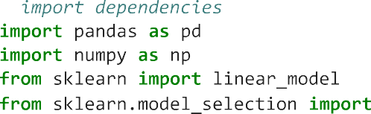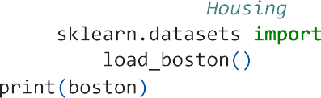









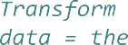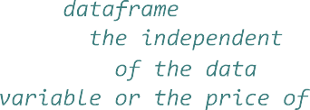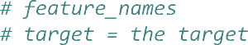







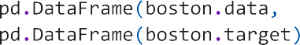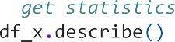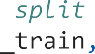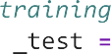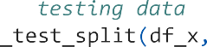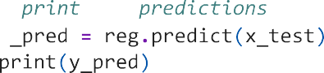



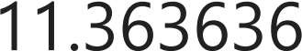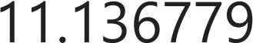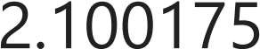



















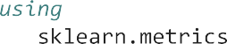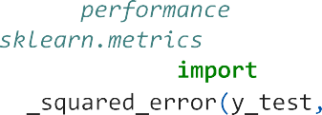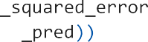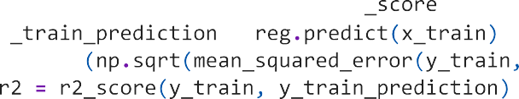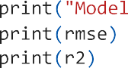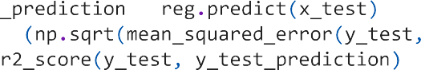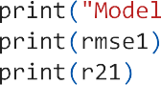

























**Group A : 05**

|  |  |
| --- | --- |
| Name | Abhishek Santosh Bankar |
| Roll No | 305A012 |
| Div | TE-1 |



import numpy as np

import matplotlib.pyplot as plt import pandas as pd

from sklearn.linear_model import LogisticRegression from sklearn.model_selection import train_test_split from sklearn.preprocessing import StandardScaler

from sklearn.metrics import confusion_matrix from sklearn import metrics

dataset = pd.read_csv('Social_Network_Ads.csv')

X = dataset.iloc[:, [2, 3]].values y = dataset.iloc[:, 4].values

X_train, X_test, y_train, y_test = train_test_split(X, y, test_size=0.20, random_state=0)

sc = StandardScaler()

X_train = sc.fit_transform(X_train) X_test = sc.transform(X_test)

classifier = LogisticRegression(random_state=0) classifier.fit(X_train, y_train)

LogisticRegression(random_state=0)

y_pred = classifier.predict(X_test)

cm = confusion_matrix(y_test, y_pred)

confusion_matrix=cm

FP = confusion_matrix.sum(axis=0) - np.diag(confusion_matrix) FN = confusion_matrix.sum(axis=1) - np.diag(confusion_matrix) TP = np.diag(confusion_matrix)

TN = confusion_matrix.sum() - (FP + FN + TP)

ACC = (TP+TN)/(TP+FP+FN+TN)

ERR = 1- ACC

PRC = TP/(TP+FP)

RCL = TP/(TP+FN)

print('True Positives (TP): ', TP[0]) print('False Positives (FP): ', FP[0]) print('True Negatives (TN): ' TN[0])

print('False Negatives (FN): ', FN[0]) print('Accuracy: ', ACC[0])

print('Error Rate: ', ERR[0])

print('Precision: ', PRC[0])

print('Recall: ', RCL[0])

True Positives (TP): 57 False Positives (FP): 5 True Negatives (TN): 17 False Negatives (FN): 1 Accuracy: 0.925

Error Rate: 0.07499999999999996

Precision: 0.9193548387096774

Recall: 0.9827586206896551

0s completed at 8:42 PM

**Group A : 06**

|  |  |
| --- | --- |
| Name | Abhishek Santosh Bankar |
| Roll No | 305A012 |
| Div | TE-1 |

import numpy as np

import matplotlib.pyplot as plt import pandas as pd

from sklearn.naive_bayes import BernoulliNB

from sklearn.model_selection import train_test_split from sklearn.preprocessing import StandardScaler

from sklearn.metrics import confusion_matrix from sklearn import metrics

from sklearn import datasets

dataset = datasets.load_iris() X = dataset.data[:, :2]

y = dataset.target

X_train, X_test, y_train, y_test = train_test_split(X, y, test_size=0.20, random_state=0)

sc = StandardScaler()

X_train = sc.fit_transform(X_train) X_test = sc.transform(X_test)

classifier = BernoulliNB()

classifier.fit(X_train, y_train)

BernoulliNB()

y_pred = classifier.predict(X_test)

cm = confusion_matrix(y_test, y_pred)

confusion_matrix=cm

FP = confusion_matrix.sum(axis=0) - np.diag(confusion_matrix) FN = confusion_matrix.sum(axis=1) - np.diag(confusion_matrix) TP = np.diag(confusion_matrix)

TN = confusion_matrix.sum() - (FP + FN + TP)

ACC = (TP+TN)/(TP+FP+FN+TN)

ERR = 1- ACC

PRC = TP/(TP+FP)

RCL = TP/(TP+FN)

print('True Positives (TP): ', TP[0]) print('False Positives (FP): ' FP[0])

print('True Negatives (TN): ', TN[0]) print('False Negatives (FN): ', FN[0]) print('Accuracy: ', ACC[0])

print('Error Rate: ', ERR[0])

print('Precision: ', PRC[0])

print('Recall: ', RCL[0])

 True Positives (TP): 9 False Positives (FP): 0 True Negatives (TN): 19 False Negatives (FN): 2

Accuracy: 0.9333333333333333

Error Rate: 0.06666666666666665

Precision: 1.0

Recall: 0.8181818181818182

0s completed at 8:49 PM

**Group A : 07**

|  |  |
| --- | --- |
| Name | Abhishek Santosh Bankar |
| Roll No | 305A012 |
| Div | TE-1 |

import nltk

nltk.download('punkt')

nltk.download('averaged_perceptron_tagger') nltk.download('wordnet')

from nltk.tokenize import word_tokenize import docx

import pandas as pd import math

[nltk_data] Downloading package punkt to /root/nltk_data... [nltk_data] Package punkt is already up-to-date!

[nltk_data] Downloading package averaged_perceptron_tagger to [nltk_data] /root/nltk_data...

[nltk_data] Package averaged_perceptron_tagger is already up-to- [nltk_data] date!

[nltk_data] Downloading package wordnet to /root/nltk_data...

[nltk_data] Package wordnet is already up-to-date!

word_Doc=docx.Document('sample_data.docx')

extractedText = word_Doc.paragraphs[0].text

tokens = word_tokenize("The quick brown fox jumps over the lazy dog") nltk.download('stopwords')

print(tokens)

[nltk_data] Downloading package stopwords to /root/nltk_data... [nltk_data] Package stopwords is already up-to-date!

['The', 'quick', 'brown', 'fox', 'jumps', 'over', 'the', 'lazy', 'dog']

tag = nltk.pos_tag(tokens) print(tag)

[('The', 'DT'), ('quick', 'JJ'), ('brown', 'NN'), ('fox', 'NN'), ('jumps', 'VBZ'), (

from nltk.corpus import stopwords

stop_words = set(stopwords.words('english'))

tokens = [w for w in tokens if not w in stop_words] print(tokens)

['The', 'quick', 'brown', 'fox', 'jumps', 'lazy', 'dog']

from nltk.stem.porter import PorterStemmer porter = PorterStemmer()

stems = []

for t in tokens:

stems.append(porter.stem(t)) print(stems)

['the', 'quick', 'brown', 'fox', 'jump', 'lazi', 'dog']

from nltk.stem import WordNetLemmatizer lemmatizer = WordNetLemmatizer()

for w in tokens:

print(lemmatizer.lemmatize(w))

 The

quick brown fox

jump lazy dog

first_sentence = word_Doc.paragraphs[1].text second_sentence = word_Doc.paragraphs[2].text

first_sentence = first_sentence.split(" ")

second_sentence = second_sentence.split(" ")#join them to remove common duplicate words total= set(first_sentence).union(set(second_sentence))

print(total)

{'job', 'machine', 'key', 'best', 'Data', 'the', 'of', '21st', 'is', 'science', 'for

wordDictA = dict.fromkeys(total, 0) wordDictB = dict.fromkeys(total, 0) for word in first_sentence:

wordDictA[word]+=1

for word in second_sentence: wordDictB[word]+=1

print(pd.DataFrame([wordDictA, wordDictB]))

job machine key best Data the of 21st is science for Science \ 0 1 0 0 1 1 2 1 1 1 0 0 1

1 0 1 1 0 0 1 0 0 1 1 1 0

century learning data 0 1 0 0

1 0 1 1

def computeTF(wordDict, doc): tfDict = {}

corpusCount = len(doc)

for word, count in wordDict.items():

tfDict[word] = count/float(corpusCount) return(tfDict)

#running our sentences through the tf function:

tfFirst = computeTF(wordDictA, first_sentence)

tfSecond = computeTF(wordDictB, second_sentence)

#Converting to dataframe for visualization tf = pd.DataFrame([tfFirst, tfSecond])

print(tf)

job machine key best Data the of 21st is science for \ 0 0.1 0.000 0.000 0.1 0.1 0.200 0.1 0.1 0.100 0.000 0.000

1 0.0 0.125 0.125 0.0 0.0 0.125 0.0 0.0 0.125 0.125 0.125

Science century learning data 0 0.1 0.1 0.000 0.000

1 0.0 0.0 0.125 0.125

def computeIDF(docList): idfDict = {}

N = len(docList)

idfDict = dict.fromkeys(docList[0].keys(), 0) for word, val in idfDict.items():

idfDict[word] = math.log10(N / (float(val) + 1))

return(idfDict)

#inputing our sentences in the log file

idfs = computeIDF([wordDictA, wordDictB]) print(idfs)

56639812, 'Data': 0.3010299956639812, 'the': 0.3010299956639812, 'of': 0.301029995663

0s completed at 9:41 PM

**Group A : 08**

|  |  |
| --- | --- |
| Name | Abhishek Santosh Bankar |
| Roll No | 305A012 |
| Div | TE-1 |

import pandas as pd import numpy as np

import seaborn as sns

df=pd.read_csv('https://raw.githubusercontent.com/datasciencedojo/datasets/master/titanic.

df.shape

(891, 12)

sns.lmplot('Age','Fare',df,hue='Survived')

/usr/local/lib/python3.7/dist-packages/seaborn/_decorators.py:43: FutureWa FutureWarning

<seaborn.axisgrid.FacetGrid at 0x7f8a2ae7ea90>

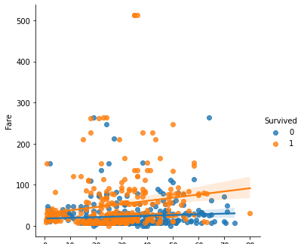

sns.scatterplot(data=df,x='Age',y='Fare',hue='Sex')

<matplotlib.axes._subplots.AxesSubplot at 0x7f8a2ae11050>

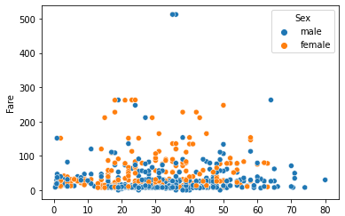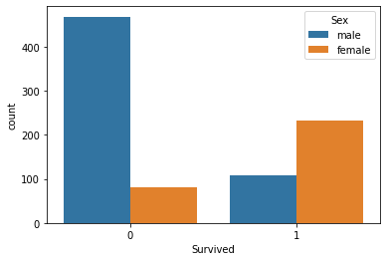

<matplotlib.axes._subplots.AxesSubplot at 0x7f8a2af0ea10>

sns.countplot(data=df,x='Survived',hue='Sex')

sns.distplot(df['Age'],kde=False,color='orange')

 /usr/local/lib/python3.7/dist-packages/seaborn/distributions.py:2619: FutureWarning: warnings.warn(msg, FutureWarning)

<matplotlib.axes._subplots.AxesSubplot at 0x7f8a2acf4b90>

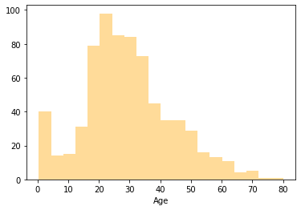

#dist plot is used

sns.distplot(df['Fare'],kde=False)

/usr/local/lib/python3.7/dist-packages/seaborn/distributions.py:2619: FutureWarning: warnings.warn(msg, FutureWarning)

<matplotlib.axes._subplots.AxesSubplot at 0x7f8a2ac9c910>

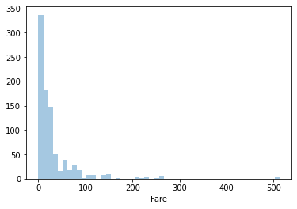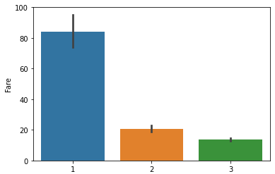

<matplotlib.axes._subplots.AxesSubplot at 0x7f8a2ac1dc50>

#which class has highest fare

sns.barplot(data=df,y='Fare',x='Pclass')

sns.countplot(data=df,x='Pclass')

<matplotlib.axes._subplots.AxesSubplot at 0x7f8a2ab03550>

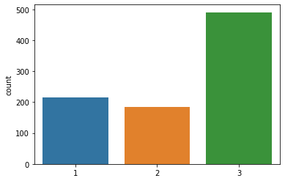

sns.countplot(data=df, y='Sex')

<matplotlib.axes._subplots.AxesSubplot at 0x7f8a2aad6dd0>

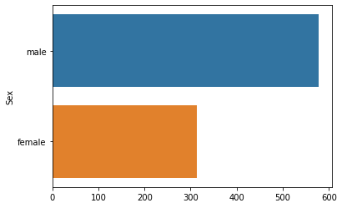

#To find

df.Pclass.value_counts()

3 491

1 216

2 184

Name: Pclass, dtype: int64

#from which classs people does't survived

sns.countplot(x='Pclass',data=df,hue='Survived')

<matplotlib.axes._subplots.AxesSubplot at 0x7f8a2aaa52d0>

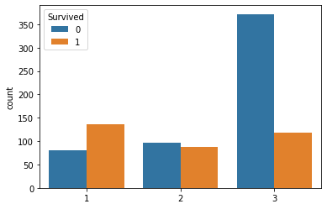

#From which station most of passangers boarded sns.countplot(data=df,x='Embarked')

<matplotlib.axes._subplots.AxesSubplot at 0x7f8a2a9b8f90>

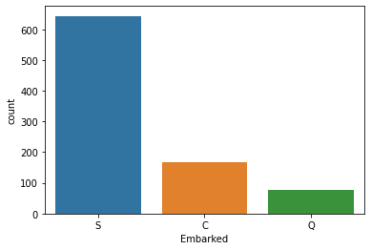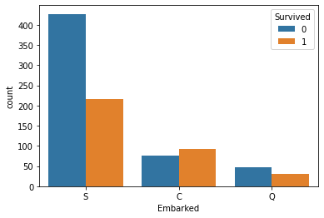

<matplotlib.axes._subplots.AxesSubplot at 0x7f8a2a9a0890>

#from which station most of people not survived

sns.countplot(data=df,x='Embarked',hue='Survived')

#for which station fare was more

sns.boxplot(data=df,x="Embarked",y='Fare')

<matplotlib.axes._subplots.AxesSubplot at 0x7f8a2a91d110>

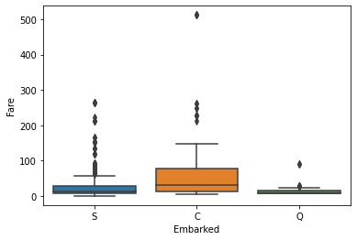

sns.scatterplot(data=df,x='Embarked',y='Fare')

<matplotlib.axes._subplots.AxesSubplot at 0x7f8a2a8a8510>

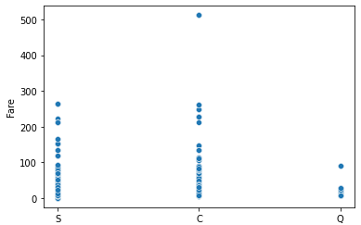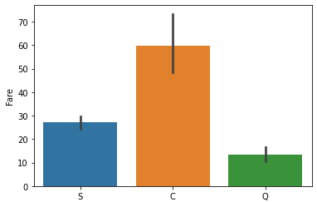

<matplotlib.axes._subplots.AxesSubplot at 0x7f8a2a81af50>

sns.barplot(data=df,x='Embarked',y='Fare')

sns.countplot(data=df,x='Survived',hue='SibSp')

<matplotlib.axes._subplots.AxesSubplot at 0x7f8a2a785f50>

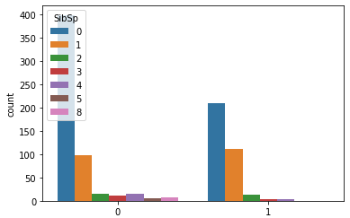

#How the fare for each passenger is distributed by plotting a histogram #dark color represents count of values is more

sns.histplot(data=df,x='PassengerId',y='Fare',binwidth=50,cbar=True)

<matplotlib.axes._subplots.AxesSubplot at 0x7f8a2a727b10>

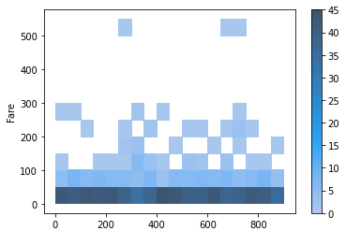

0s completed at 9:55 PM

**Group A : 09**

|  |  |
| --- | --- |
| Name | Abhishek Santosh Bankar |
| Roll No | 305A012 |
| Div | TE-1 |

import pandas as pd import seaborn as sns

df=pd.read_csv('https://raw.githubusercontent.com/datasciencedojo/datasets/master/titanic.

df.head()

**Name**

|  |  |  |
| --- | --- | --- |
| **PassengerId** | **Survived** | **Pclass** |
| **0** 1 | 0 | Brau  3 Mr. Ow |
|  |  | Ha |
|  |  | Cumi Mrs. |
| **1** 2 | 1 | 1 Bra |

|  |  |  |  |  |
| --- | --- | --- | --- | --- |
| **Sex** | **Age** | **SibSp** | **Parch** |  |
| male | 22.0 | 1 | 0 | A/ |
| female | 38.0 | 1 | 0 | P |

**2** 3 1 3

nd, en rris

ngs, John dley

(Florence

Briggs Th...

Heikkinen,

Miss. female 26.0 0 0 ST

3

df.shape

(891, 12)

df.Age.unique()

array([22. , 38. , 26. , 35. , nan, 54. , 2. , 27. , 14. ,

|  |  |  |  |  |  |  |  |  |  |  |  |  |  |  |  |  |  |
| --- | --- | --- | --- | --- | --- | --- | --- | --- | --- | --- | --- | --- | --- | --- | --- | --- | --- |
| 4. | , | 58. | , | 20. | , | 39. | , | 55. | , | 31. | , | 34. | , | 15. | , | 28. | , |
| 8. | , | 19. | , | 40. | , | 66. | , | 42. | , | 21. | , | 18. | , | 3. | , | 7. | , |
| 49. | , | 29. | , | 65. | , | 28.5 | , | 5. | , | 11. | , | 45. | , | 17. | , | 32. | , |
| 16.  71. | ,  , | 25.  37. | ,  , | 0.83,  47. , | | 30.  14.5 | ,  , | 33.  70.5 | ,  , | 23.  32.5 | ,  , | 24.  12. | ,  , | 46.  9. | ,  , | 59.  36.5 | ,  , |
| 51.  45.5 | ,  , | 55.5  20.5 | ,  , | 40.5  62. | ,  , | 44.  41. | ,  , | 1.  52. | ,  , | 61.  63. | ,  , | 56.  23.5 | ,  , | 50. ,  0.92, | | 36.  43. | ,  , |

60. , 10. , 64. , 13. , 48. , 0.75, 53. , 57. , 80. ,

70. , 24.5 , 6. , 0.67, 30.5 , 0.42, 34.5 , 74. ])

df.Survived.unique()

array([0, 1])

df.Sex.value_counts()

male 577

female 314

Name: Sex, dtype: int64

sns.countplot(data=df,x='Sex',hue='Survived')

<matplotlib.axes._subplots.AxesSubplot at 0x7f61058ed790>

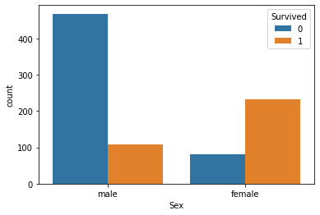

sns.boxplot(data=df,x='Sex',y='Age',hue='Survived')

<matplotlib.axes._subplots.AxesSubplot at 0x7f61057ec110>

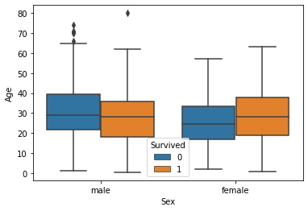

# We have plotted the graph gender vs Age and setted hue as Survived. From above boxplot we can infer that

### Maximum age in data is 40.

1. Female count of survival is greater the=an male count of survival.

### Least age in the data is 18.

1. Survived female age group is between 18 to 40.

### More older men died than younger men.

**Group A : 10**

|  |  |
| --- | --- |
| Name | Abhishek Santosh Bankar |
| Roll No | 305A012 |
| Div | TE-1 |



import pandas as pd

import matplotlib.pyplot as plt import seaborn as sns

import numpy as np

df=pd.read_csv("https://gist.githubusercontent.com/netj/8836201/raw/6f9306ad21398ea43cba4f

df.head()

|  |  |  |  |  |  |  |
| --- | --- | --- | --- | --- | --- | --- |
| **sepal.length** | | **sepal.width** | **petal.length** | **petal.width** | **variety** |  |
| **0** 5.1 | | 3.5 | 1.4 | 0.2 | Setosa |
| **1** 4.9 | | 3.0 | 1.4 | 0.2 | Setosa |
| **2** 4.7 | | 3.2 | 1.3 | 0.2 | Setosa |
| **3** 4.6 | | 3.1 | 1.5 | 0.2 | Setosa |
| **4** 5.0 | | 3.6 | 1.4 | 0.2 | Setosa |
| df.tail() |  |  |  |  |  | |
|  | **sepal.length** | **sepal.width** | **petal.length** | **petal.width** | **variety** | |
| **145** | 6.7 | 3.0 | 5.2 | 2.3 | Virginica | |
| **146** | 6.3 | 2.5 | 5.0 | 1.9 | Virginica | |
| **147** | 6.5 | 3.0 | 5.2 | 2.0 | Virginica | |
| **148** | 6.2 | 3.4 | 5.4 | 2.3 | Virginica | |
| **149** | 5.9 | 3.0 | 5.1 | 1.8 | Virginica | |

df.shape

(150, 5)

df.columns

Index(['sepal.length', 'sepal.width', 'petal.length', 'petal.width', 'variety'],

dtype='object')

df["sepal.length"].unique()

|  |  |  |  |  |  |  |  |  |
| --- | --- | --- | --- | --- | --- | --- | --- | --- |
| array([5.1, | 4.9, | 4.7, | 4.6, | 5. , | 5.4, | 4.4, | 4.8, | 4.3, 5.8, 5.7, 5.2, 5.5, |
| 4.5, | 5.3, | 7. , | 6.4, | 6.9, | 6.5, | 6.3, | 6.6, | 5.9, 6. , 6.1, 5.6, 6.7, |
| 6.2, | 6.8, | 7.1, | 7.6, | 7.3, | 7.2, | 7.7, | 7.4, | 7.9]) |

df["sepal.width"].unique()

|  |  |  |  |  |  |  |  |  |
| --- | --- | --- | --- | --- | --- | --- | --- | --- |
| array([3.5, 3. , 3.2, 3.1, | 3.6, | 3.9, | 3.4, | 2.9, | 3.7, | 4. , 4.4, | 3.8, | 3.3, |
| 4.1, 4.2, 2.3, 2.8, | 2.4, | 2.7, | 2. , | 2.2, | 2.5, | 2.6]) |  |  |

df["petal.length"].unique()

|  |  |  |  |  |  |  |  |  |  |  |  |  |
| --- | --- | --- | --- | --- | --- | --- | --- | --- | --- | --- | --- | --- |
| array([1.4, | 1.3, | 1.5, | 1.7, | 1.6, | 1.1, | 1.2, | 1. , | 1.9, | 4.7, | 4.5, | 4.9, | 4. , |
| 4.6, | 3.3, | 3.9, | 3.5, | 4.2, | 3.6, | 4.4, | 4.1, | 4.8, | 4.3, | 5. , | 3.8, | 3.7, |
| 5.1, | 3. , | 6. , | 5.9, | 5.6, | 5.8, | 6.6, | 6.3, | 6.1, | 5.3, | 5.5, | 6.7, | 6.9, |
| 5.7, | 6.4, | 5.4, | 5.2]) |  |  |  |  |  |  |  |  |  |

df["petal.width"].unique()

array([0.2, 0.4, 0.3, 0.1, 0.5, 0.6, 1.4, 1.5, 1.3, 1.6, 1. , 1.1, 1.8,

1.2, 1.7, 2.5, 1.9, 2.1, 2.2, 2. , 2.4, 2.3])

df["sepal.length"].value_counts().sum()

150

df["sepal.length"].value_counts()

|  |  |
| --- | --- |
| 5.0 | 10 |
| 5.1 | 9 |
| 6.3 | 9 |
| 5.7 | 8 |
| 6.7 | 8 |
| 5.8 | 7 |
| 5.5 | 7 |
| 6.4 | 7 |
| 4.9 | 6 |
| 5.4 | 6 |
| 6.1 | 6 |
| 6.0 | 6 |
| 5.6 | 6 |
| 4.8 | 5 |
| 6.5 | 5 |
| 6.2 | 4 |
| 7.7 | 4 |
| 6.9 | 4 |
| 4.6 | 4 |
| 5.2 | 4 |
| 5.9 | 3 |
| 4.4 | 3 |
| 7.2 | 3 |
| 6.8 | 3 |
| 6.6 | 2 |
| 4.7 | 2 |
| 7.6 | 1 |
| 7.4 | 1 |
| 7.3 | 1 |
| 7.0 | 1 |
| 7.1 | 1 |
| 5.3 | 1 |
| 4.3 | 1 |

7.9 1

Name: sepal.length, dtype: int64

df["sepal.width"].value_counts()

|  |  |  |
| --- | --- | --- |
| 3.0 | 26 |  |
| 2.8 | 14 |  |
| 3.2 | 13 |  |
| 3.4 | 12 |  |
| 3.1 | 11 |  |
| 2.9 | 10 |  |
| 2.7 | 9 |  |
| 2.5 | 8 |  |
| 3.5 | 6 |  |
| 3.3 | 6 |  |
| 3.8 | 6 |  |
| 2.6 | 5 |  |
| 2.3 | 4 |  |
| 3.6 | 4 |  |
| 3.7 | 3 |  |
| 2.4 | 3 |  |
| 2.2 | 3 |  |
| 3.9 | 2 |  |
| 4.4 | 1 |  |
| 4.0 | 1 |  |
| 4.1 | 1 |  |
| 4.2 | 1 |  |
| 2.0  Name: | 1  sepal.width, | dtype: int64 |

df["petal.length"].value_counts()

|  |  |
| --- | --- |
| 1.4 | 13 |
| 1.5 | 13 |
| 5.1 | 8 |
| 4.5 | 8 |
| 1.6 | 7 |
| 1.3 | 7 |
| 5.6 | 6 |
| 4.7 | 5 |
| 4.9 | 5 |
| 4.0 | 5 |
| 4.2 | 4 |
| 5.0 | 4 |
| 4.4 | 4 |
| 4.8 | 4 |
| 1.7 | 4 |
| 3.9 | 3 |
| 4.6 | 3 |
| 5.7 | 3 |
| 4.1 | 3 |
| 5.5 | 3 |
| 6.1 | 3 |
| 5.8 | 3 |
| 3.3 | 2 |
| 5.4 | 2 |
| 6.7 | 2 |

|  |  |
| --- | --- |
| 5.3 | 2 |
| 5.9 | 2 |
| 6.0 | 2 |
| 1.2 | 2 |
| 4.3 | 2 |
| 1.9 | 2 |
| 3.5 | 2 |
| 5.2 | 2 |
| 3.0 | 1 |
| 1.1 | 1 |
| 3.7 | 1 |
| 3.8 | 1 |
| 6.6 | 1 |
| 6.3 | 1 |
| 1.0 | 1 |
| 6.9 | 1 |
| 3.6 | 1 |
| 6.4 | 1 |
| Name: | petal.length, dtype: int64 |

df["petal.width"].value_counts()

|  |  |  |
| --- | --- | --- |
| 0.2 | 29 |  |
| 1.3 | 13 |  |
| 1.8 | 12 |  |
| 1.5 | 12 |  |
| 1.4 | 8 |  |
| 2.3 | 8 |  |
| 1.0 | 7 |  |
| 0.4 | 7 |  |
| 0.3 | 7 |  |
| 2.1 | 6 |  |
| 2.0 | 6 |  |
| 0.1 | 5 |  |
| 1.2 | 5 |  |
| 1.9 | 5 |  |
| 1.6 | 4 |  |
| 2.5 | 3 |  |
| 2.2 | 3 |  |
| 2.4 | 3 |  |
| 1.1 | 3 |  |
| 1.7 | 2 |  |
| 0.6 | 1 |  |
| 0.5  Name: | 1  petal.width, | dtype: int64 |

df["sepal.length"].dtype

dtype('float64')

df["sepal.width"].dtype

dtype('float64')

df["petal.length"].dtype

dtype('float64')

df["petal.width"].dtype

dtype('float64')

PART 1

#LIST DOWN THE FEATURES AND THEIR TYPES

df.columns

Index(['sepal.length', 'sepal.width', 'petal.length', 'petal.width', 'variety'],

dtype='object')

df["sepal.length"].dtype

dtype('float64')

df["sepal.width"].dtype

dtype('float64')

df["petal.length"].dtype

dtype('float64')

df["petal.width"].dtype

dtype('float64')

sns.countplot(data=df,x="variety") plt.title("Species Count")

Text(0.5, 1.0, 'Species Count')

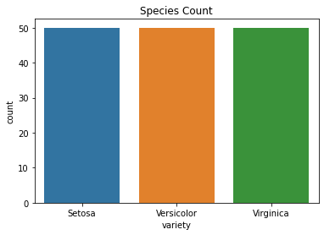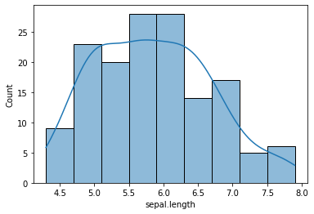

PART 2

<matplotlib.axes._subplots.AxesSubplot at 0x7feb1a501310>

sns.histplot(data=df,x="sepal.length",kde=True)

#CREATE HISTOGRAM FOR EACH FEATURE IN DATASET TO ILLUSTRATE FEATRURE DISTRIBUTION

sns.histplot(data=df,x="sepal.width",kde=True)

<matplotlib.axes._subplots.AxesSubplot at 0x7feb1a544690>

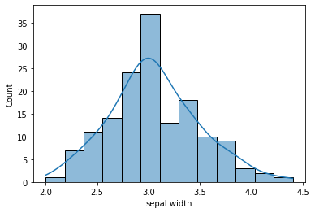

sns.histplot(data=df,x="petal.length",kde=True)

<matplotlib.axes._subplots.AxesSubplot at 0x7feb1a3a7410>

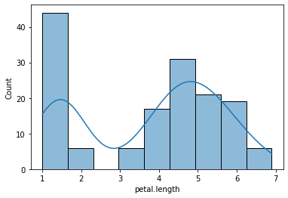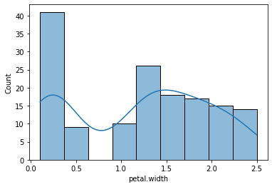

<matplotlib.axes._subplots.AxesSubplot at 0x7feb1a3d0a90>

sns.histplot(data=df,x="petal.width",kde=True)

## PART 3

#CREATE A BOX PLOT FOR EACH FEATURE IN THE DATASET

sns.boxplot(data=df,x="sepal.length")

<matplotlib.axes._subplots.AxesSubplot at 0x7feb1a2b2e90>

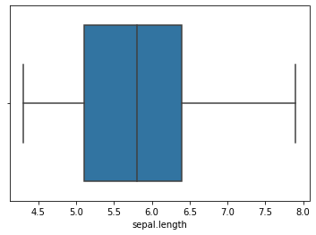

sns.boxplot(data=df,x="sepal.width")

<matplotlib.axes._subplots.AxesSubplot at 0x7feb1a7b7050>

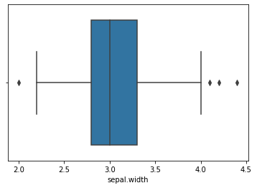

sns.boxplot(data=df,x="petal.length",y="variety")

<matplotlib.axes._subplots.AxesSubplot at 0x7feb1a6e6910>

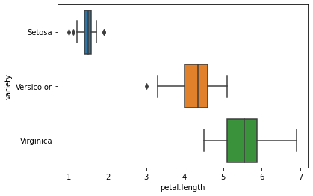

sns.boxplot(data=df,x="petal.width",y="variety")

<matplotlib.axes._subplots.AxesSubplot at 0x7feb1a162ad0>

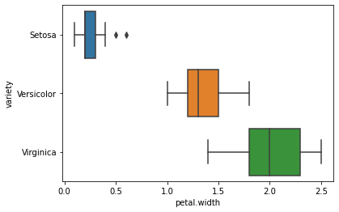

## PART 4

#COMPARE DISTRIBUTIONS AND OUTLIERS

sns.boxplot(data=df,x="sepal.length")

<matplotlib.axes._subplots.AxesSubplot at 0x7feb1a10f690>



sns.boxplot(data=df,x="sepal.width")

<matplotlib.axes._subplots.AxesSubplot at 0x7feb1a0744d0>



sns.boxplot(data=df,x="petal.length")

<matplotlib.axes._subplots.AxesSubplot at 0x7feb19fe0e50>

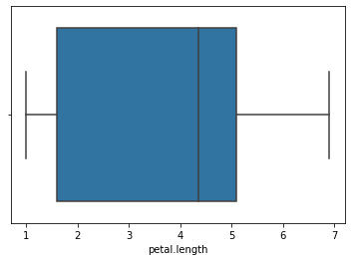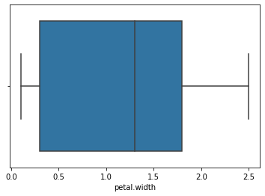

<matplotlib.axes._subplots.AxesSubplot at 0x7feb19fcf450>

sns.boxplot(data=df,x="petal.width")

0s completed at 10:03 PM